Thrive not just survive grant 2020  consent form | 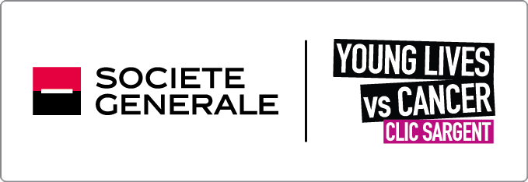
If you are reading this, you are likely to be thinking about getting in touch about our Thrive Not Just Survive grant.
What is it?
We have an amount of money that we are looking to provide to individual young people aged 14 to 24 year olds who have had cancer or a bone marrow failure. This grant is in partnership with our corporate partner Societe Generale.
What can I use the grant for?
The grant is to help you to achieve an education or career ambition. You can find out more by visiting: www.clicsargent.org.uk/thrive
Why the consent form?
Here at CLIC Sargent we take our responsibility to look after your data and information seriously. This form is to make sure you (and your parents or carers) know who will read your application, why and that you provide written agreement to this.
Who will see my application?
As we have a set amount of money, we have to look at all the applications and decide in a fair way who we can, and who we can’t award this grant too. To do this a panel of CLIC Sargent and Societe Generale staff will need to review your application.
As part of this shortlisting process we would like to share your application with a select group of Societe Generale staff members so we can carry this out collaboratively.
Your information will only be shared for the purposes of this grant application and will not be used for any other reasons. Your application will not be shared with any other third party.

Please indicate if you are happy for us to share your application with employees of Societe Generale:
Yes

No

Applying for the silver or gold award?
If you receive a silver or gold grant for £1000 or more, we would need to contact you again about how the grant has made a difference to you achieving your ambition. This will be for up to two years after you have received it.
Please indicate that you are happy to help us with evaluating the impact of the grant:
Yes

No

Your details are safe with us. For more information about how CLIC Sargent uses your information, please read our privacy policy.
You can update your preferences at any time by calling us on 02087522939, emailing TNJS@clicsargent.org.uk or searching ‘CLIC Sargent keeping in touch’.

Child / Young Person
Name: ……………………………………………………….
Signed (required if independent young adult 16 or over in Scotland, or 18 and over in the rest of the UK): …………………………
Date: ….........................................

If your age on the 30 September 2020 is under 16 and you live in Scotland, or under 18 if you live elsewhere in the UK, a Family Member / Carer is required to sign here before your application can be considered.
Name: ……………………………………………………….
Relationship: ……………………….
Signed: …………………………………………
Date: ….........................................

